Approval Form for Artificial Intelligence (AI) Product

Section 1: Product Information

1 | Product Name | MRI Prostate Segmentation Assistant (PSA)
2 | Product Owner | MRI PSA project team  Name: Tran Nguyen Tuan Anh  Designation: Consultant  Signature:  
3 | Product Description | MRI PSA is a project funded by the SGH Innovation Grant and designed to assist radiologists with prostate contouring when preparing for MRI–US fusion biopsy.  Currently, patients undergo prostate MRI, after which the MRI findings are discussed with the urologist. If an MRI-targeted biopsy is indicated, a separate biopsy request is submitted.  Under the current workflow, the reporting SGH radiologist manually contours the prostate and marks suspicious biopsy targets on the Biobot Surgical robotic platform. MRI PSA aims to streamline this process by generating preliminary prostate contours and tumour targets for the radiologist to review and modify. This is expected to improve radiologists’ productivity by reducing time spent on this repetitive task.
4 | Product Benefits | Efficiency  The solution is expected to improve radiologists’ efficiency by automating the repetitive task of manually contouring the prostate.  Patient safety  The prostate MRI will already have been independently reported before the decision to proceed with biopsy; therefore, the solution is expected to pose minimal additional risk to patients.  Human oversight  All model outputs serve only as a starting point for review and editing by the radiologist, ensuring that the radiologist remains firmly in the loop.
Section 2: Usage of Product

1 | Where will the AI-MD be deployed? | Tick where applicable  ☒SGH  ☐ KKH  ☐ CGH  ☐ SKH  ☐ SCH  ☐ SNEC  ☐ NHCS  ☐ NCCS  ☐ NDCS  ☐ NNI  ☐ SHP
2 | Where is the machine learning model intended to be deployed at? | Tick where applicable  ☐ SingHealth Machine Learning Server (MLS)  ☐ AIM.sg  ☒ Others (please state): On-premise CARPL platform (previously hosted an AISG-funded project RAPIER, and currently hosting Lunit Mammo AI solution)
Section 3: Human Involvement

1 | What is the degree of human involvement?  - Human-in-the-loop (manual): Human oversight is active and involved, with the human retaining full control and the AI only providing recommendation or input. Decisions cannot be exercised without affirmative actions by the human, such as a human command to proceed with a given decision.  - Human-over-the-loop (semi-autonomous): Human oversight is involved to the extent that human is in a monitoring or supervisory role, with the ability to take over control when the AI model encounters unexpected or undesirable events (such as model failure).  - Human-out-of-the-loop (autonomous): There is no human oversight over the execution of decisions. The AI has full control without the option of human override. | Tick one only  ☒ Human-in-the-loop  ☐ Human-over-the-loop  ☐ Human-out-of-the-loop
Section 4: Product Certifications

1 | Has the AI-MD been certified by any external bodies, e.g. HSA, FDA? | No  If Yes, please list the certification bodies:  N/A
Section 5: Building of AI Model

1 | What are the datasets used to train the AI model? | The prostate organ and lesion models used retrospective, de-identified SGH prostate MRI examinations and the public PROSTATEx dataset.  The SGH dataset consisted of 3,477 retrospective MRI studies performed at SGH and its imaging centers between 1 January 2023 to 30 September 2025. Of those, only cases meeting specialist-radiologist review and technical quality criteria were included for subsequent training.  Lesion cohort composition: 865 SGH lesion-positive, 333 radiologist-reviewed SGH true-negative and 200 lesion-positive PROSTATEx examinations.
  Model component | Eligible cohort | Development design
  Prostate organ segmentation | N=1,751: 1,547 SGH + 204 PROSTATEx | 1,223 training  264 validations  264 locked tests
  Lesion segmentation | N=1,398: 1,198 SGH + 200 PROSTATEx | 1,189 in five-fold cross-validation  209 locked tests
2 | Where do the datasets originate from? | Tick where appropriate  ☒ SGH  ☐ KKH  ☐ CGH  ☐ SKH  ☐ SCH  ☐ SNEC  ☐ NHCS  ☐ NCCS  ☐ NDCS  ☐ NNI  ☒ Others: Open-source dataset as supplement
3 | What is the general quality assessment of the dataset used for AI model training, testing and validation? (To ensure representativeness of datasets to reduce unintended bias) | Of 3,477 SGH examinations assigned for review, 2,550 were fully reviewed by specialist radiologists. Of the reviewed examinations:  - 1,547 cases were selected for organ segmentation model training  - 1,198 cases were selected for lesion segmentation model training  Quality controls  - All MRI scans, organ and lesion contours used for model training were reviewed and evaluated by subspecialist radiologists  - MRI images of T2W, DWI and ADC were reviewed in conjunction to evaluate the tumor mask.  - Only a subset of cases where image quality, organ contour, and lesion detection were deemed satisfactory for model training.  Scanner mix among eligible SGH cases was approximately:  - 64-65% Siemens  - 20% GE  - 15-16% Philips  This mix mirrors the actual clinical mix during the period from 2023-2025.
4 | What is the performance of the AI model? (Evaluate and validate the performance to ensure it minimally meets the clinical practice baseline) | Development-validation results
  Model | Validation basis | Dice | Additional metrics
  Prostate organ | 264 cases; selected epoch 626 | 0.95447 | Precision 0.95228; recall 0.95781
  Lesion | Five-fold out-of-fold; 1,189 unique cases | 0.47891 | Sensitivity 73.62% (773/1,050 lesions); 0.743 false positives/case
Section 6: AI Model Clinical Evaluation

1 | Has the AI model been validated in parallel to “live” clinical settings or actual use in the case of a clinical trial? | No  This will be part of the validation process in our SGH-Innovation-Grant project.  If yes, please provide the clinical trial validation results.  N/A
2 | Have the clinical trial validation results been published or presented at any forum? | No  If yes, please state the name of publication/forum:  N/A
3 | What is the source of live data used to validate the AI model? (e.g. eHints subject area xyz, etc) | The model was primarily trained on the same source of data that it will be deployed on (SGH MRI Prostate data)
4 | What is the performance of the AI model on a live population in a clinical setting(s) with actual input data? | We have not deployed this in-house model in a live clinical setting.  However, due to the nature of this workflow, the input data are retrospective in nature, as the MRI prostate scans would have been reported and its findings discussed with patients by the ordering clinicians. We don't expect much difference between our training dataset and the actual live deployment.
Section 7: Patient Treatment Workflow

1 | Will there be any changes to the existing patient treatment workflow? | No
2 | If there are no changes, please provide a diagram to describe the workflow.  If there are changes, please provide diagrams to describe the workflow before and after the changes. | BEFORE  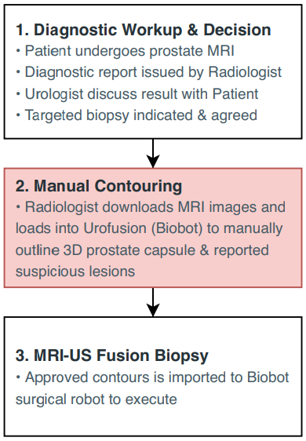  AFTER  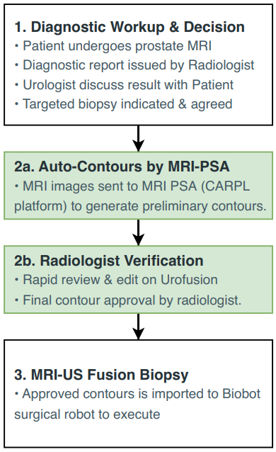
3 | Will the treatment be invasive to the patient? | No
4 | Who is the primary decision maker? | Healthcare professional  The radiologist has the final decision on the final contour and proposed biopsy target. If the radiologist disagrees with the model output, he/she can disregard the model’s suggestion and start from scratch.
Section 8: Periodic Review and Validation of AI Model

1 | What is the proposed frequency of periodic review and downstream validation of the AI model? | Others  If Others, please state the frequency:  Limited deployment will be performed for the remaining duration of the MRI PSA project. Our aim is to ensure seamless technical integration between the model, CARPL platform, and Biobot's medical software (Urofusion). Direct feedback from participating radiologists will be collected to further refine the model performance.
Section 9: Evaluation

1 | We have reviewed and assessed that the information in this form is correct and in order.  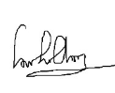  Supported by:    Dr LOW SU CHONG ALBERT Dr Sarat Kumar Sanamandra  _______________________________ _________________________  Name & Designation Name & Designation  HOD Independent Specialist  Dept of Cardiothoracic and Abdominal Radiology Senior Consultant  Dept of NeuroRadiology  ________________________  Name & Designation  Chief Data and Digital Officer  (where applicable)  Remarks:
2 | Reviewed by:  ______________________________ ________________________  Name & Designation Name & Designation  Office of Insights and Analytics SingHealth AI Office  ______________________________  Name & Designation  Office of Data and Digital Governance  Remarks:

REFERENCE:

